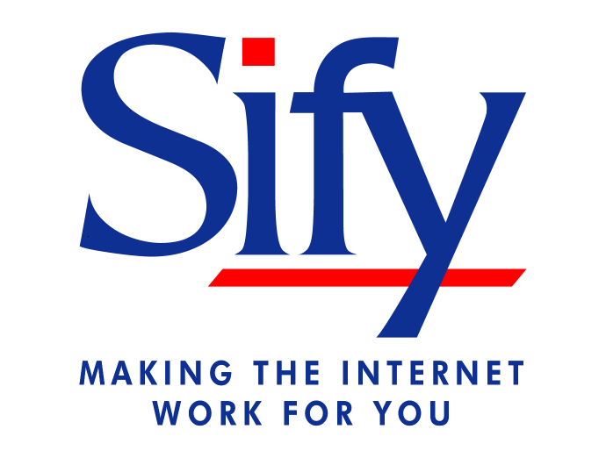

Dear Associate,

The details of Code of Conduct & Conflict of Interest Policy of our Company is enclosed.

At Sify, we expect all associates to conduct themselves in a manner that enhances the image & reputation of the organisation. We also expect that our associates conduct business activities in a manner that does not create a conflict of interest between the associate and the company.

While you may be called upon to make decisions on behalf of the organisation, you need to make such decisions within the Policy framework that has been outlined in the booklet. While the Policy has attempted to cover a number of areas, it is obviously not comprehensive.

Kindly go through the document very carefully and understand its contents, especially in terms of how it applies to you.

Regards,

Raju Vegesna
CEO & Managing Director

CODE OF CONDUCT

The Company expects associates to adhere to the rules of conduct & behaviour while conducting Company’s business. The Company’s Policy on the same is as follows:
- Carryout ones roles and responsibilities effectively and efficiently to maximize business for the Company.

- Follow all policies, procedures and internal control systems of the Company.

- Obey the laws of the country while carrying out ones work.

- Behave with integrity and honesty.

- Accept accountability.

- Communicate openly.

- Treat people fairly and with dignity and respect.

- Handle all customer contacts with the highest standard of professionalism and courtesy.

- Report to work/external meetings/training as scheduled.

- Effectively utilize ones time at work and avoid spending it on personal activities and phone calls.

- Keep superiors informed when leave of absence is required.

- Report to work in appropriate attire. (in line with the Company’s dress code).

The Company will not accept and will not tolerate the following behavior from an associate:
- Being intoxicated on Company’s premises or while conducting Company’s business.

- Consuming alcoholic beverages either on the premises of the Company or Company business partners.

- Entering into fights either on the premises of the Company or Company business partners.

- Using rude, abusive or obscene language with a customer, business partner or a colleague. Disconnecting a customer’s, business partner’s or a colleague’s call without providing appropriate services.

- Refusing to serve a customer or carryout reasonable orders (relating to work) of a superior.

CONFLICT OF INTEREST

GUIDELINES

An associate of the Company has a duty to avoid financial or other business relationships that might be adverse to the interests of the Company, create the appearance of (or have the potential of producing) conflicting loyalties or interests, or interfere with effective job performance.

The Company requires it’s associates to conduct business activities to the highest ethical standards and take action to avoid personal and business situations that create conflict, competition, or tension between the Company’s interest and the interest or loyalty of the associate.

Below are some examples of conduct covered by this policy that could create potential conflict of interest:

- Associate shall not own a material interest in, or act as an officer, director, employee or consultant on behalf of any supplier, contractor, or customer of the company.

- The Company discourages gifts, trips, entertainment, loans or other favors from contractors, suppliers, customers or business partners. However, small business gifts of an advertising nature or reasonable business entertainment in the course of Company’s business may be accepted where the value of the gift or business activity does not exceed Rs. 1000. If the gift or business entertainment exceeds the limits of this Policy, the associate should seek the approval of the SBU Head/Managing Director.

- Associates shall not use information, or Company facilities and assets in a manner that will be detrimental to the Company. An associate shall not use for his or her own benefit information developed through Company’s research or development activities, or disclose confidential or unpublished information obtained through associates connected with the Company, during the course of employment or even after separating from the services of the Company.

- Associate shall not be employed gainfully elsewhere or take a part-time job without the explicit permission of the Management.

- Associate shall not use Company’s assets or facilities for their personal benefit. Company’s assets or facilities referred to in this policy includes but is not limited to computer hardware and software, communications facilities and Company provided access to the Internet.

- Associate shall be responsible for protecting the company’s Intellectual property, Copyrights and Proprietary information. Proprietary information is any information created, acquired or controlled by the Company, which the Company has determined should not be published or released to others. It includes, but is not limited to, financials, billing records, unannounced products and services, technical information, sales and marketing data and employee records.

- Associate shall also protect the proprietary information and copyrights of the Company’s business partners or products used by the company.

- Associate shall not seek to own or acquire property or interests through the use of confidential or unpublished Company information. Associates should not attempt to own any interest or property where the value of the property is likely to be influenced by Company’s action.

- Associate shall not convert business opportunities, which are reasonably anticipated to be of interest to the company, for his or her own benefit, nor diverted by the associate for the benefit of others.

- Associates shall not own (directly or indirectly) material interest in the enterprise of a competitor of the Company. In addition, no associate should act as a director, office partner, consultant, employee or agent of any enterprise in competition with the Company or its business partners.

- When an associate leaves the Company, all the documents and records containing proprietary information must be returned to the Company.

- Even after employment ends, the former associate will continue to be obliged not to divulge any proprietary information to any other person, party or competitor for a period of one year from the date of separation from the Company.

- If an associate is in doubt of any proposed activity or action which will adversely affect the Company’s interest or violates this Policy, he / she must check the proposed activity with the SBU Head/Managing Director through their supervisor. An associate will proceed to undertake any such proposed activity or action only after obtaining approval from the SBU head/Managing Director.

- You shall neither directly or indirectly work or do consultancy or engage in any such services for any organization, company or firm which is a subsidiary or parent of a company which is in direct competition to the business of Sify for a period of one year from the date of leaving the services of the company.

Non-Solicitation:
While you are employed by Sify and for a one year period after leaving the services of the company, for any reason whatsoever, you will not without prior written permission from the company directly or indirectly (whether alone or as a partner, joint venturer, consultant, officer, director, investor, employee, agent or independent contractor) whether for yourself or on behalf of any other person or entity actually or attempt to:
a) Solicit, persuade, hire or employ any employee of Sify
b) Solicit business from any Sify customers or potential customers on whose account or with whom you dealt with while in employment, for a similar business/activity, which is in competition with Sify.
c) Knowingly permit any person or entity that employs you or that is directly or indirectly controlled by you to engage in any of the conduct prohibited by this Non-Solicitation section.

No Conflicting Obligations:
You also represent that you will not bring with you or disclose to Sify, or use in the performance of your responsibilities at Sify, any confidential information not generally available to the public of a former employer or any other party, unless you have obtained written authorization for its possession and use. You also agree that, during your employment by Sify, you shall abide by any confidentiality obligations you may owe to any former employer or other party. You also agree and represent that you are not bound by any valid agreement or obligation of non-competition or non-solicitation to any former employers or other parties.

ACKNOWLEDGEMENT

- I acknowledge that I have received and read the policy titled “Company’s Code of Conduct and Conflict of Interest” and I understand my employment with the company will be terminated if I violate the conditions stated in this Policy.

- I acknowledge that I have read the policy on Conflict of interest and I agree;

- Not to use any company facility or resources, including computer hardware and software, communications facilities and company access to the Internet in a manner detrimental to the Company or in violation of this Policy.

- I will not use any information obtained from the Company in a manner detrimental to the Company. I will not make any unauthorized disclosure of confidential or published information, documents, or data obtained through or my association with the Company during the tenure with the Company or even after leaving the services of the Company as per the conditions of this policy.

I understand that the Policy on Conflict of Interest requires that I report in advance to my SBU Head/Managing Director any commitment on my part that might involve me in a conflict of interest of the kind set forth in the Policy.

Name:

Signature:

Date:

